Tanzania

## Respect for rule of law (ROL) data

The data set shows the data on the respect of the rule of law for the country.

## # A tibble: 19 x 5  
## country iso3c date ruleOfLaw ruleOfLawCategory4   
## <chr> <chr> <dbl> <dbl> <chr>   
## 1 Tanzania TZA 1996 -0.186 ROL moderately disrespected  
## 2 Tanzania TZA 1998 -0.209 ROL moderately disrespected  
## 3 Tanzania TZA 2000 -0.347 ROL moderately disrespected  
## 4 Tanzania TZA 2002 -0.343 ROL moderately disrespected  
## 5 Tanzania TZA 2003 -0.249 ROL moderately disrespected  
## 6 Tanzania TZA 2004 -0.356 ROL moderately disrespected  
## 7 Tanzania TZA 2005 -0.279 ROL moderately disrespected  
## 8 Tanzania TZA 2006 -0.442 ROL moderately disrespected  
## 9 Tanzania TZA 2007 -0.373 ROL moderately disrespected  
## 10 Tanzania TZA 2008 -0.349 ROL moderately disrespected  
## 11 Tanzania TZA 2009 -0.480 ROL moderately disrespected  
## 12 Tanzania TZA 2010 -0.486 ROL moderately disrespected  
## 13 Tanzania TZA 2011 -0.511 ROL moderately disrespected  
## 14 Tanzania TZA 2012 -0.529 ROL moderately disrespected  
## 15 Tanzania TZA 2013 -0.473 ROL moderately disrespected  
## 16 Tanzania TZA 2014 -0.395 ROL moderately disrespected  
## 17 Tanzania TZA 2015 -0.372 ROL moderately disrespected  
## 18 Tanzania TZA 2016 -0.376 ROL moderately disrespected  
## 19 Tanzania TZA 2017 -0.447 ROL moderately disrespected

## Respect for rule of law (ROL) trend

The plot shows the trend of the respect for the rule of law for the country.

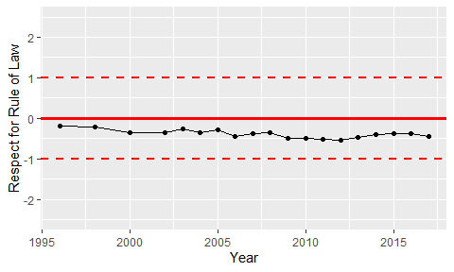

Trend of the Respect for the Rule of Law